HW1 Report

電機三B07901146 林宏軒

1. 四種sorter比較

|  |  |  |  |  |  |  |  |  |
| --- | --- | --- | --- | --- | --- | --- | --- | --- |
| Input Size | IS | | MS | | QS | | HS | |
|  | CPU time(s) | Memory (KB) | CPU time(s) | Memory (KB) | CPU time(s) | Memory (KB) | CPU time(s) | Memory (KB) |
| 4000.case2 | 0 | 12424 | 0.001 | 12424 | 0.008999 | 12424 | 0.001 | 12424 |
| 4000.case3 | 0.007999 | 12424 | 0.001 | 12424 | 0.011997 | 12440 | 0.001 | 12424 |
| 4000.case1 | 0.006999 | 12424 | 0.002 | 12424 | 0.001 | 12424 | 0 | 12424 |
| 16000.case2 | 0 | 12572 | 0.002 | 12572 | 0.120982 | 12572 | 0.001999 | 12572 |
| 16000.case3 | 0.122982 | 12572 | 0.002 | 12572 | 0.13498 | 12868 | 0.002 | 12572 |
| 16000.case1 | 0.064991 | 12572 | 0.003999 | 12572 | 0.002 | 12572 | 0.002 | 12572 |
| 32000.case2 | 0 | 12572 | 0.002 | 12624 | 0.420936 | 12572 | 0.003999 | 12572 |
| 32000.case3 | 0.424935 | 12572 | 0.002 | 12628 | 0.493924 | 13236 | 0.002999 | 12572 |
| 32000.case1 | 0.221996 | 12572 | 0.003999 | 12620 | 0.004 | 12572 | 0.003999 | 12572 |
| 1000000.case2 | 0.002 | 18592 | 0.06899 | 20372 | 370.814 | 18592 | 0.127981 | 18592 |
| 1000000.case3 | 406.014 | 18592 | 0.069989 | 20376 | 338.903 | 30500 | 0.123981 | 18592 |
| 1000000.case1 | 203.095 | 18592 | 0.159976 | 20376 | 0.116983 | 18592 | 0.19997 | 18592 |

1. 圖表

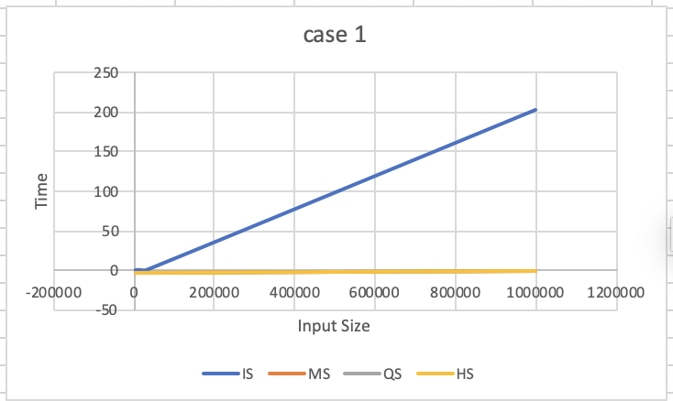

Case 1是random order的test case，average case中，其他演算法都是nlogn，只有IS是 $n^{2}$，所以可以看到IS最慢

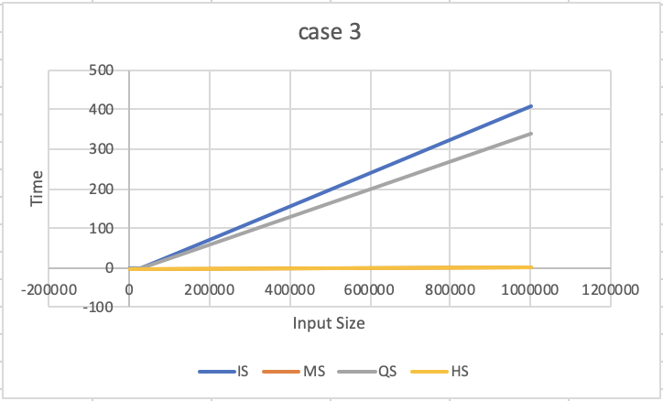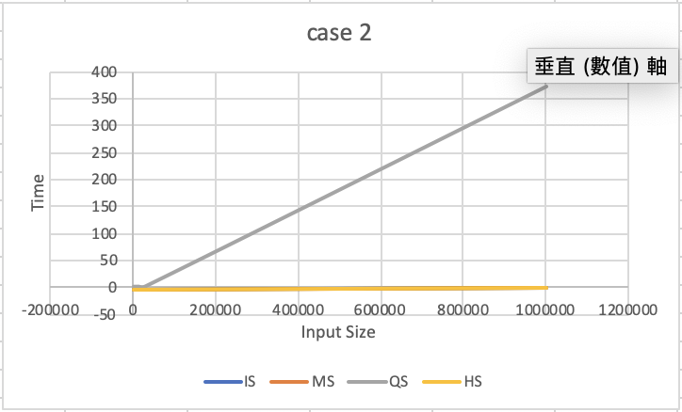Case 2是排好的test case，因為QS我選的pivot是第一個，所以case 2對QS是worst case，他的時間會最慢為 ${O(n}^{2})$

Case 3是順序相反的test case，因為QS我選的pivot也是第一個，所以case 2對QS是worst case，時間為 ${O(n}^{2})$，但對IS來說也是worst case，時間為 ${O(n}^{2})$，從塗上可以看到，IS還是最慢的